**CRM UAT Test Feedback**

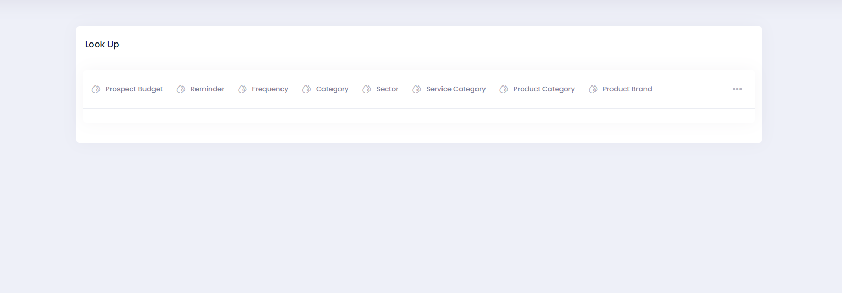

Disappearance of the created category and return to blank page after creation/deletion.

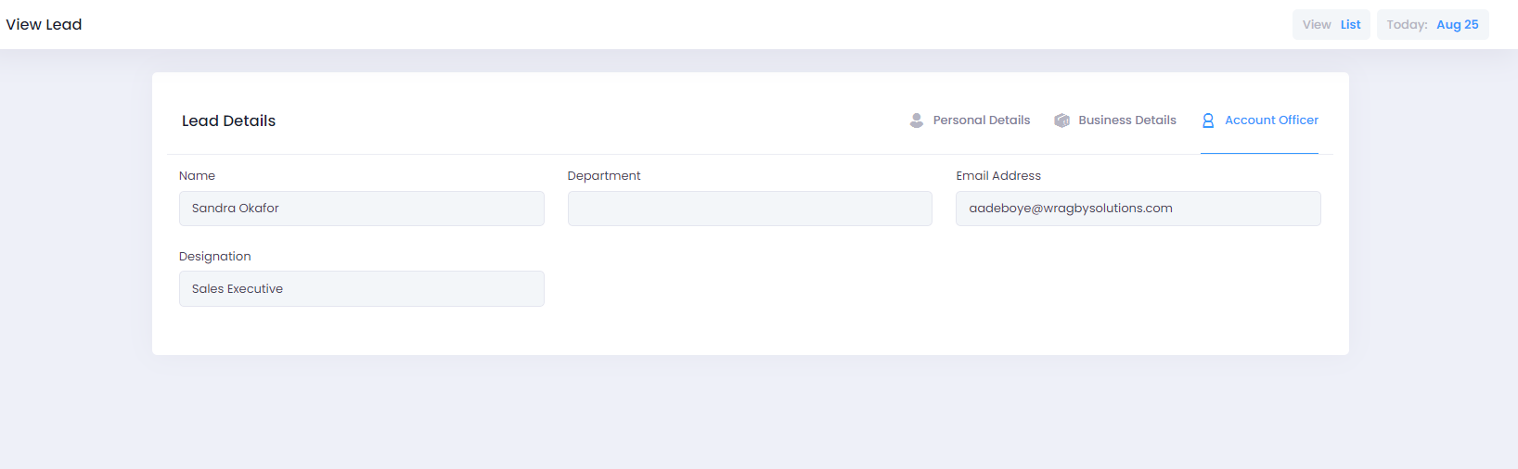

The department field is left blank after submission.

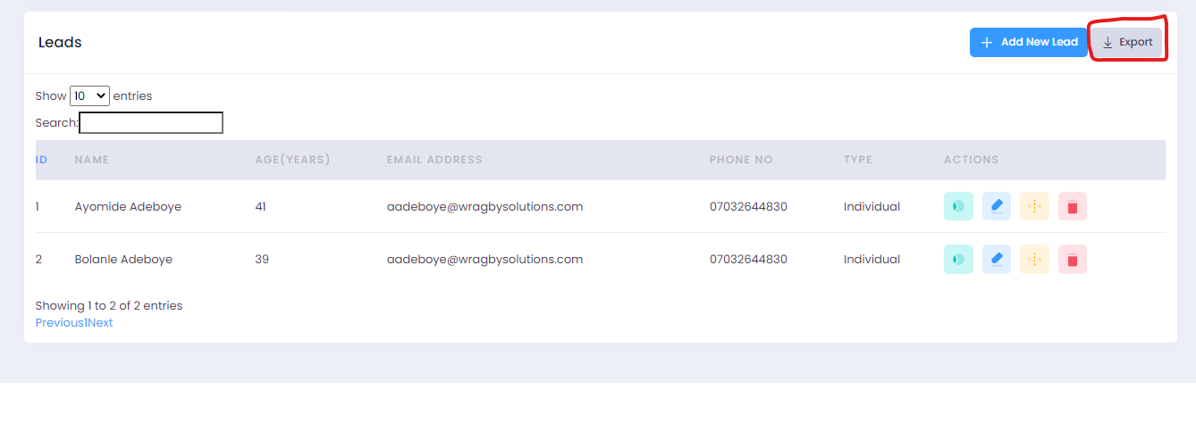

The export button is not functional.

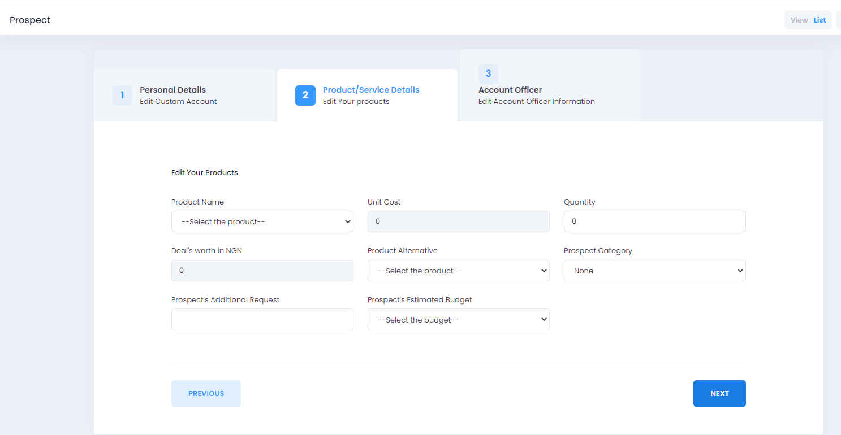

The Unit cost is not populated and not editable, likewise the deal’s worth in NGN. The quantity keeps returning to zero upon selection.

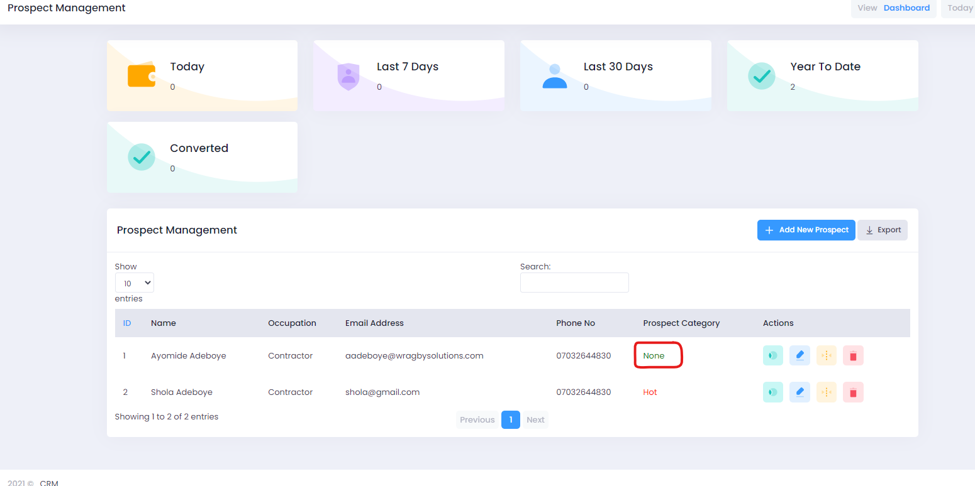

When Prospect Category was edited to “Hot” it is not updated on the data table.

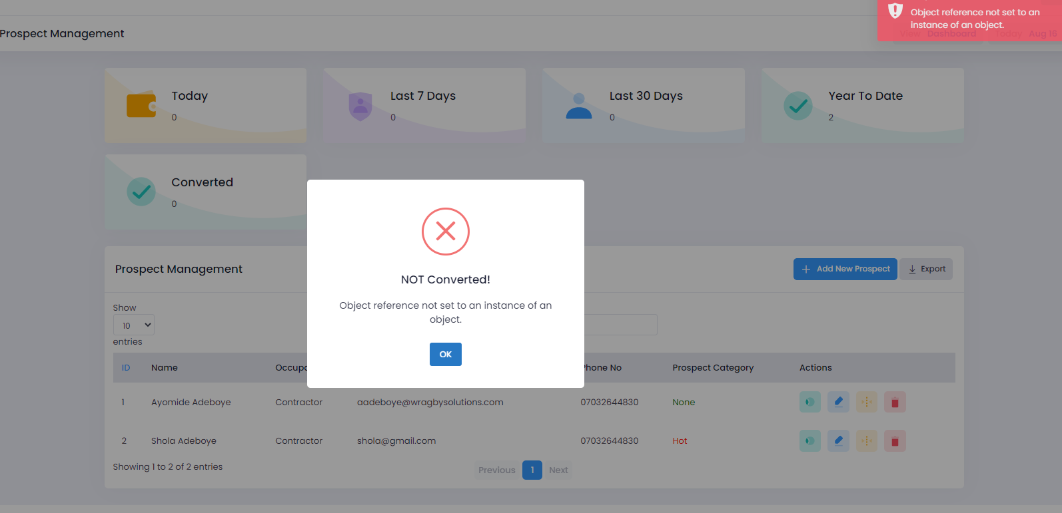

Conversion of Prospect to Customer is not working.

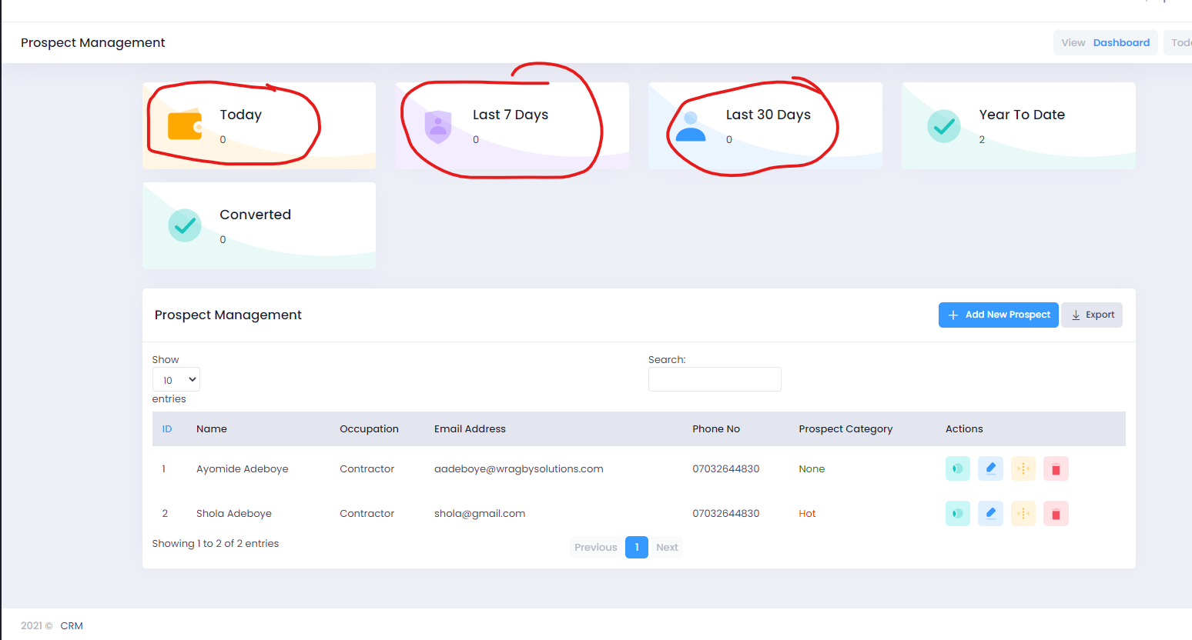

The circled counters were not updated.

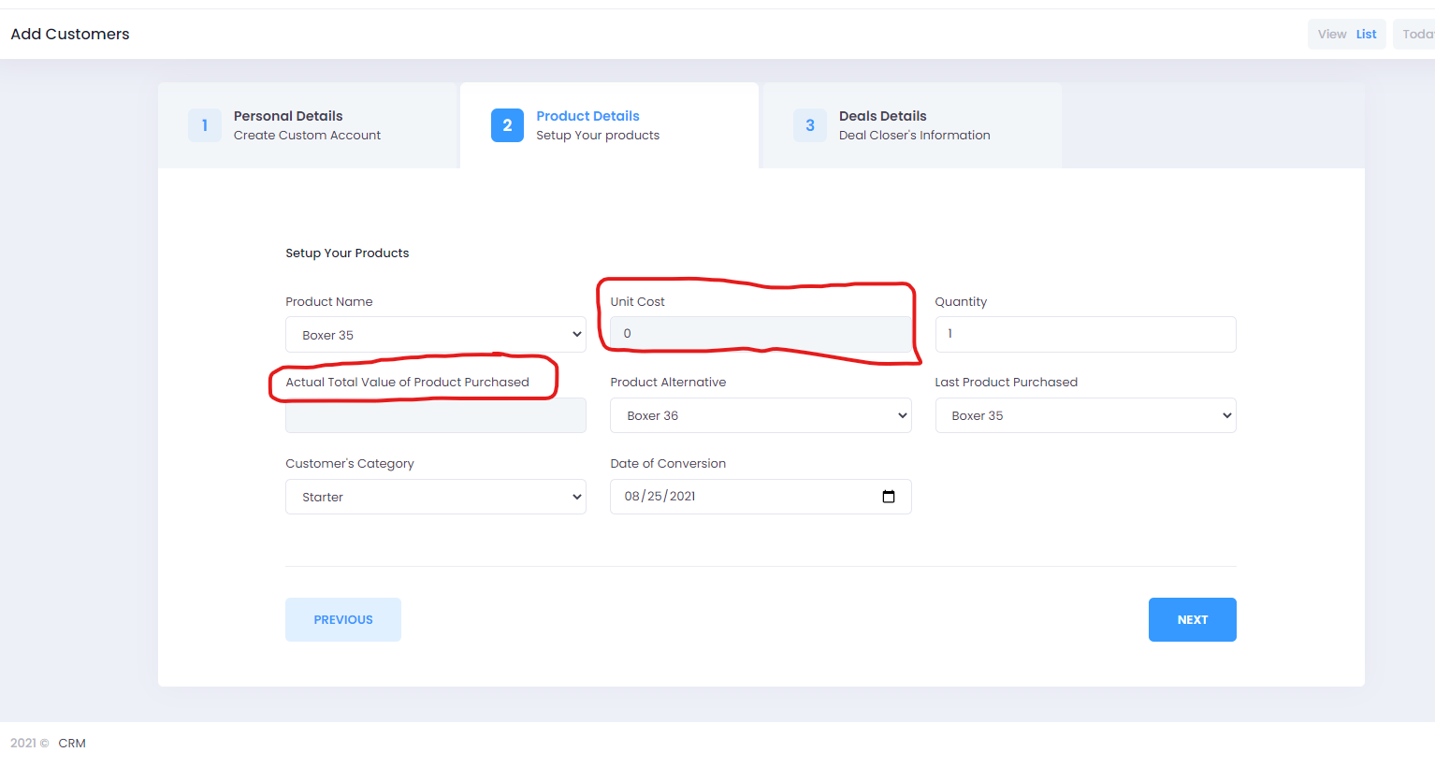

The highlighted fields are not functional.

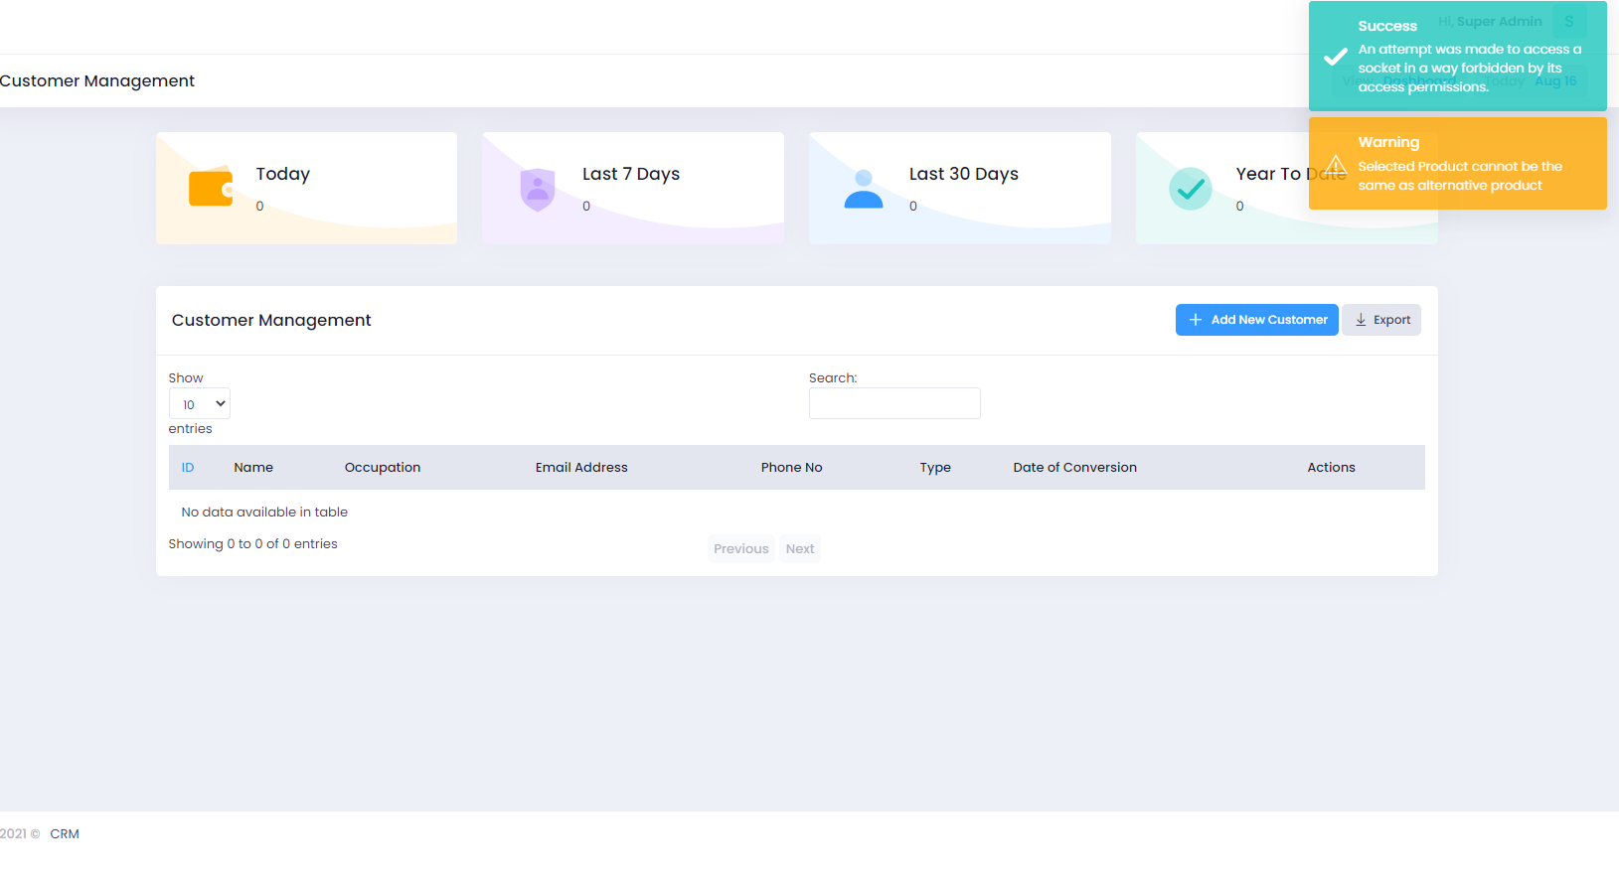

Upon creation of customer, the data table is not populated.

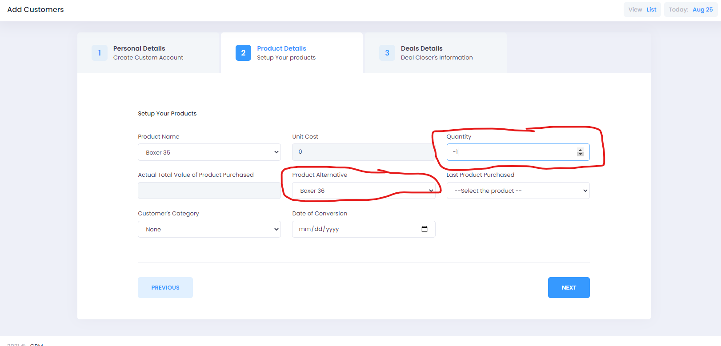

The counter in the quantity field cannot be negative. The “Product Alternative field is having an entirely new product aside what was purchased and still, customer was not created on the data table.

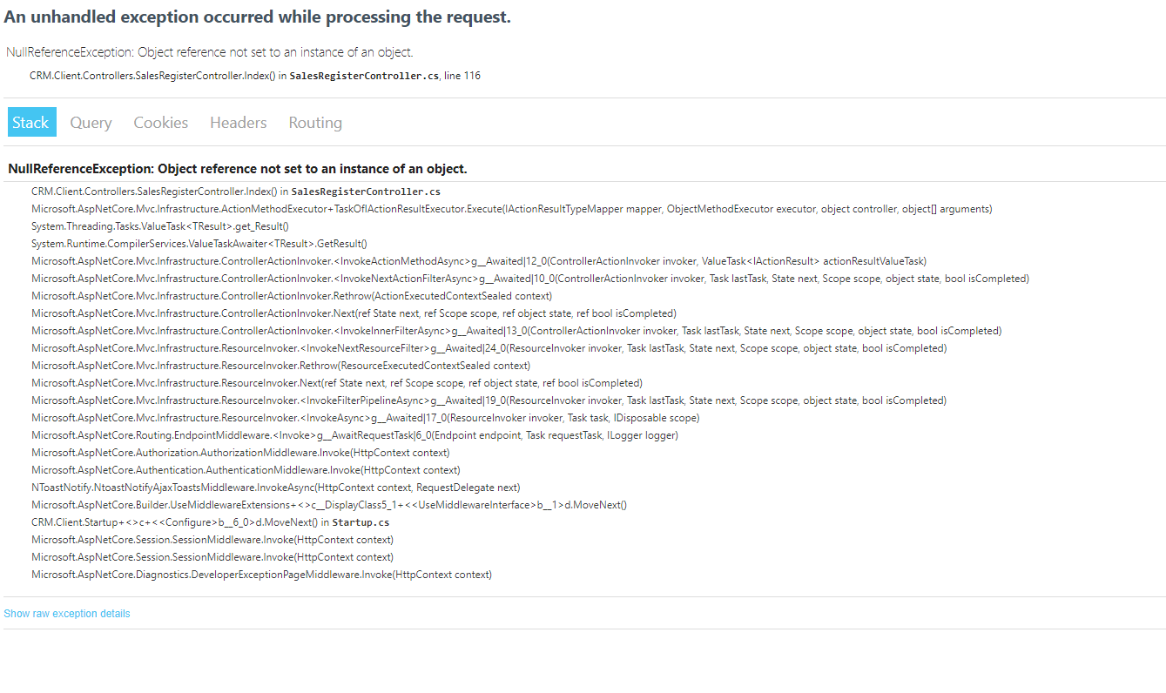

Getting Null Error for Sales Register.

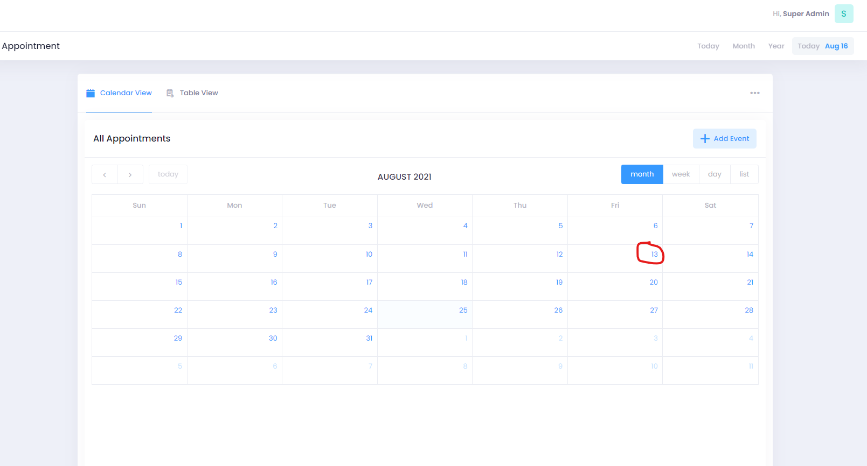

Upon clicking the date, one cannot fix an appointment except one clicks on “Add Event”.

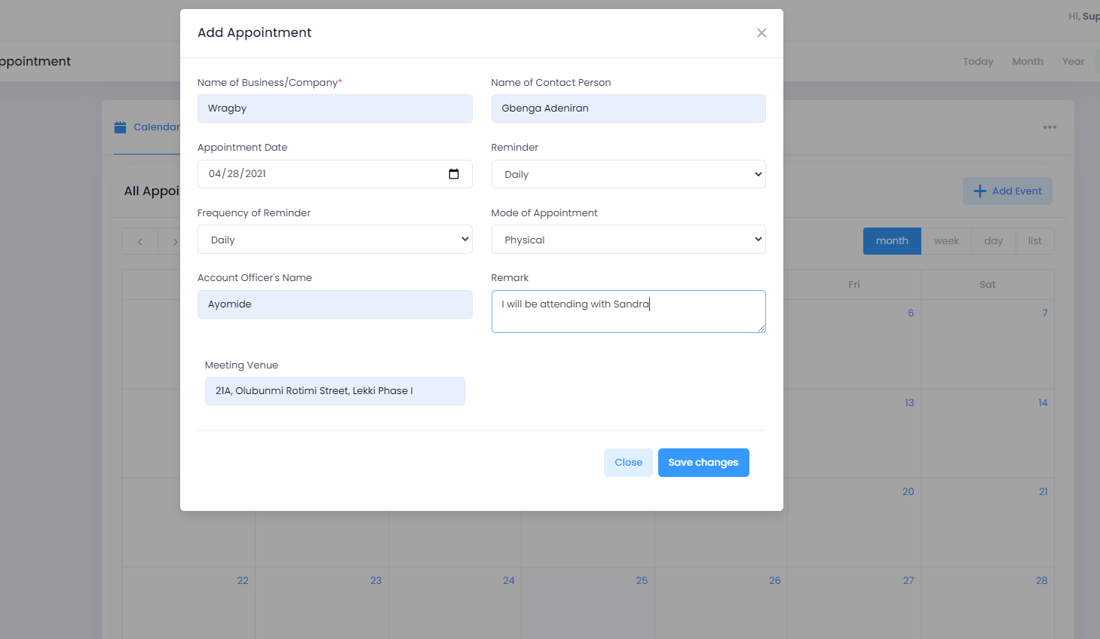

Upon capturing the information to fix an appointment, the date on the calendar was not highlighted and no record of the appointment was found on the data table.

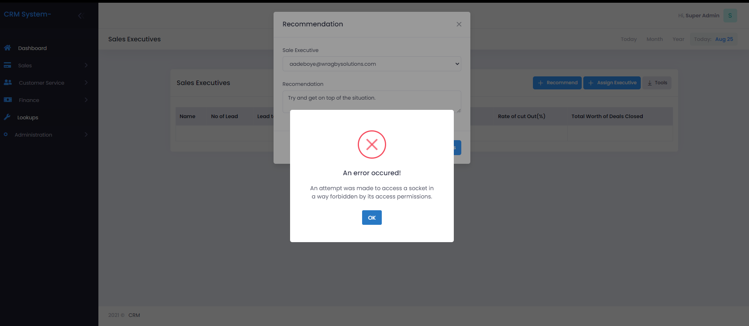

Got an Error trying to recommend to a sales executive as the Sales Manager.

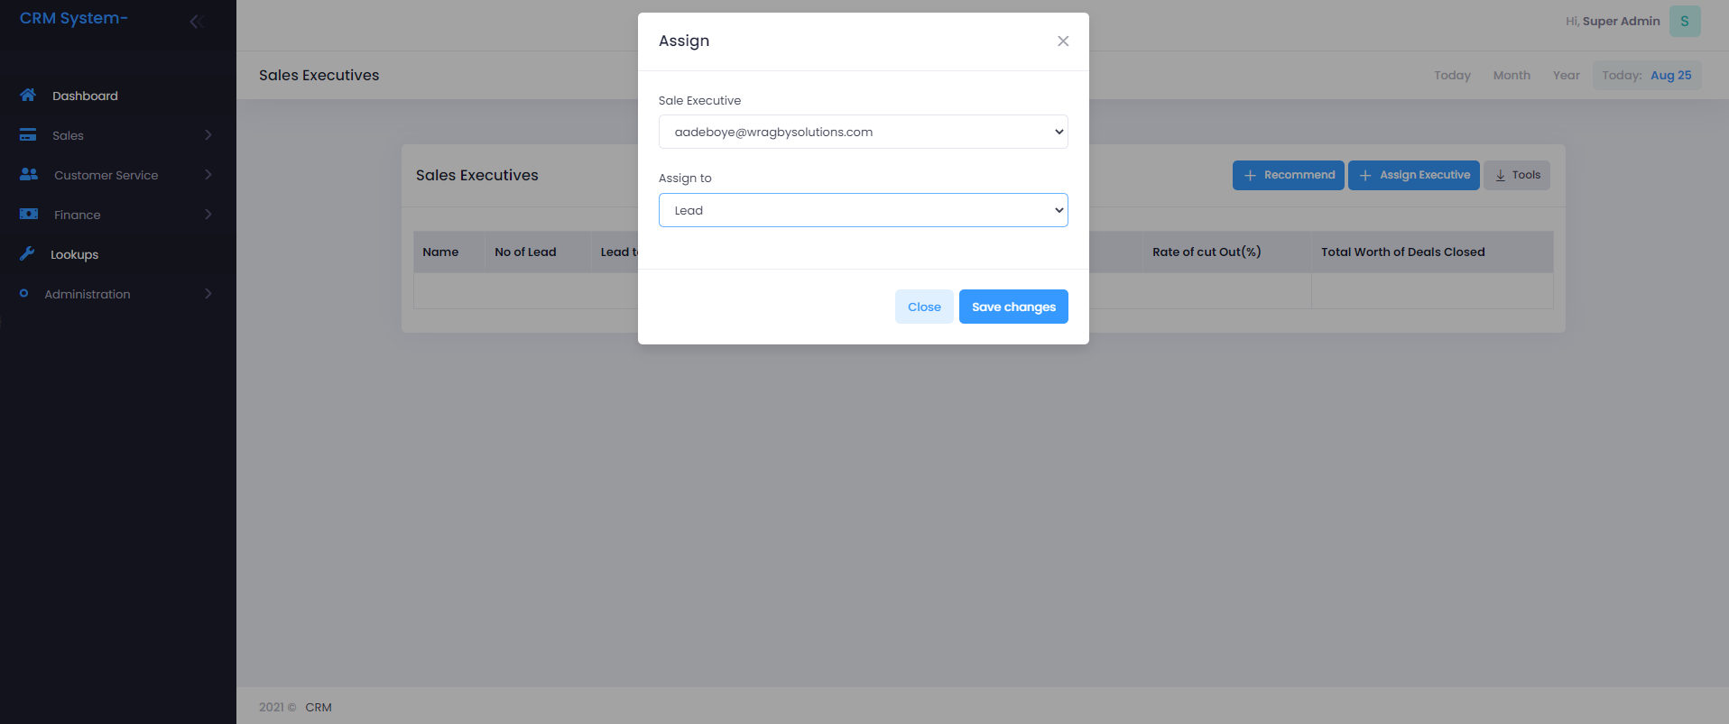

Upon selecting the lead in the drop down, I was not provided the field to select from all the onboarded leads. The sales executive should be assigned by name and email should be sent to their emails respectively at the backend. (That is, instead of assigning one by email address, pick by name and since the system already has their email register as account officers or one of the onboarded license, the system can pick the email in question).

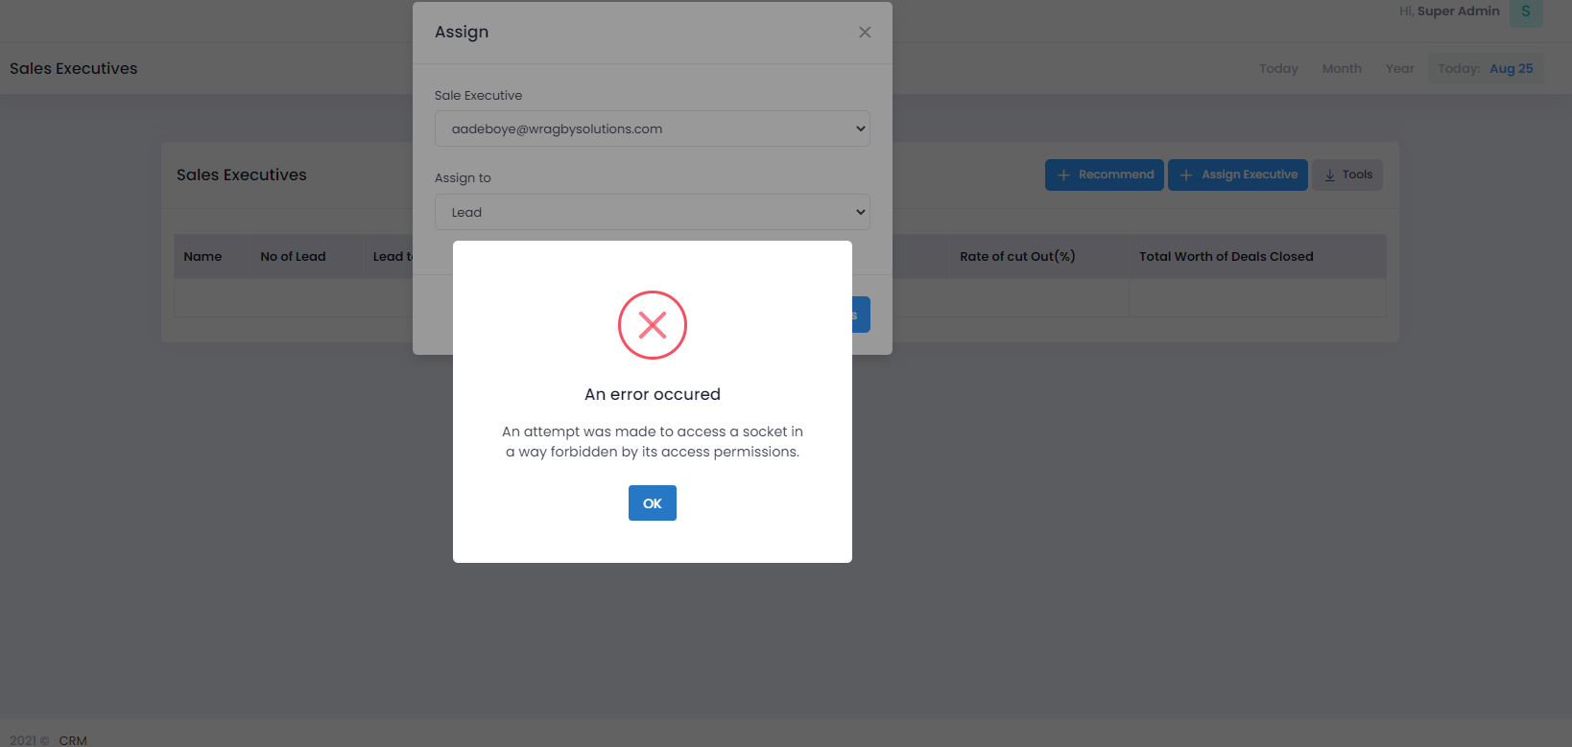

Still getting this error while trying to assign a sales executive.

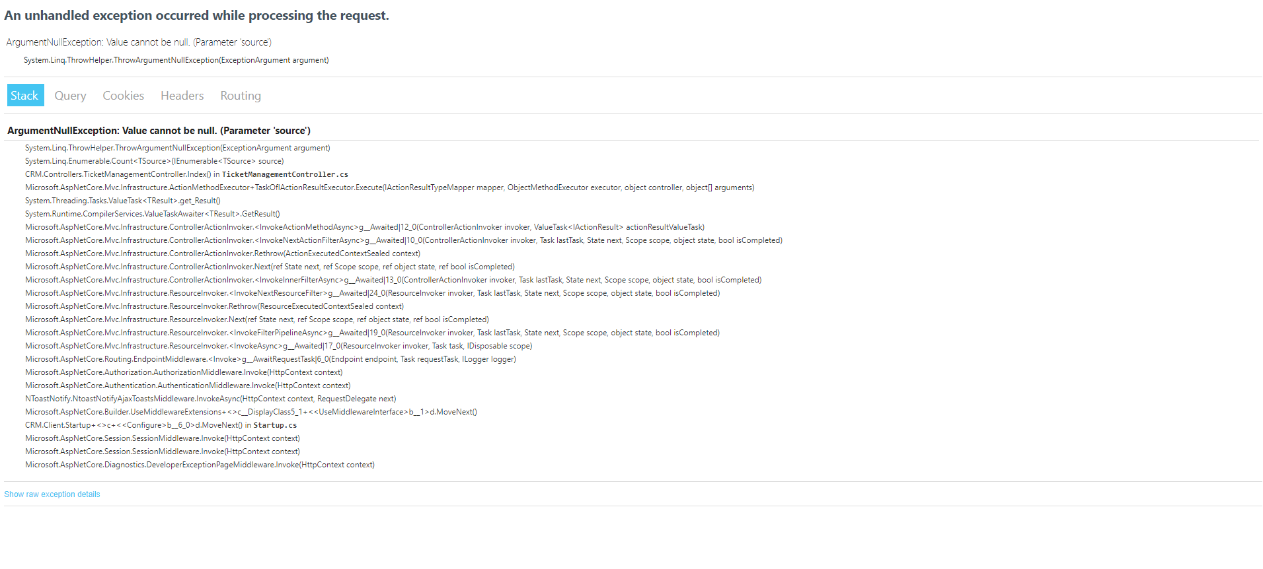

Getting a null on Complaint and Ticket Management.

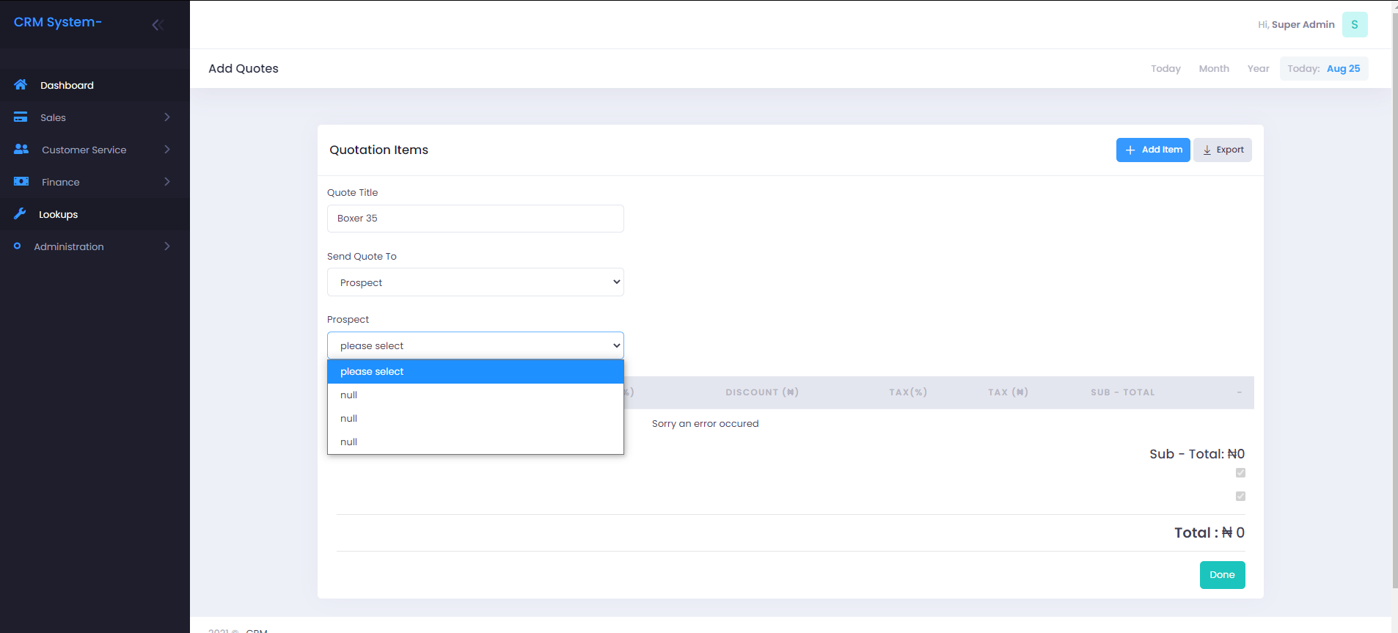

I am getting a null response where I am supposed to select the prospect, I want to send my quote to.

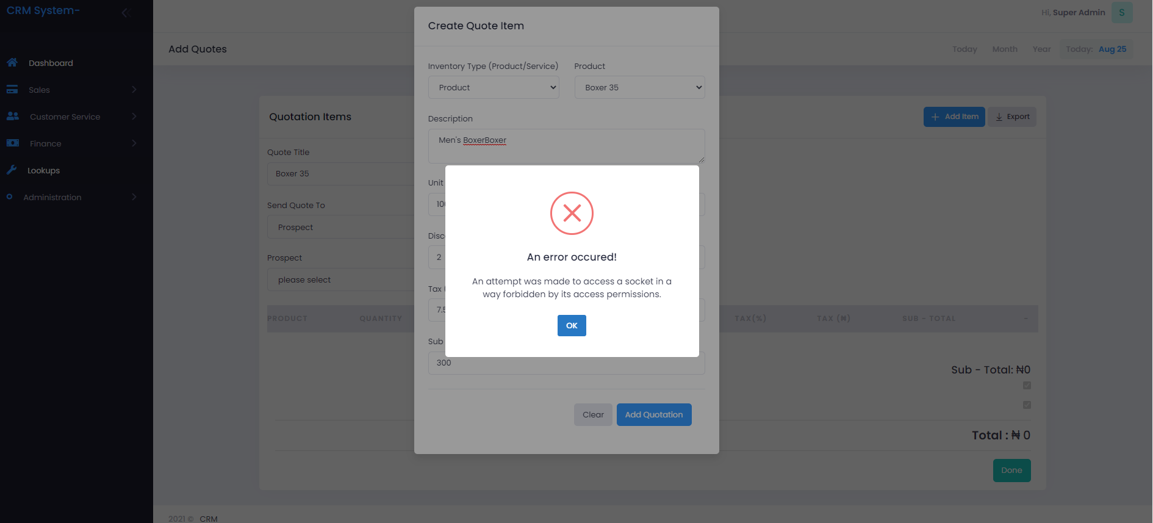

Was unable to raise quote.

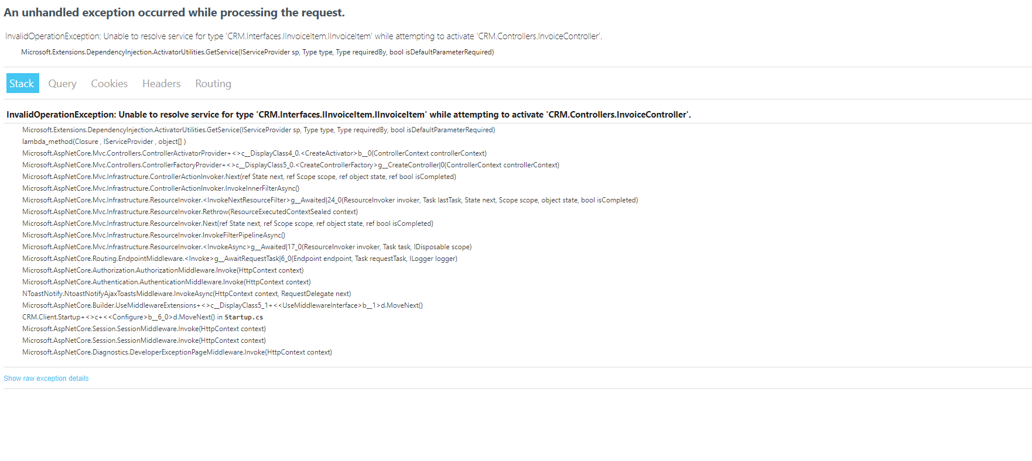

Getting Null Error for invoice.

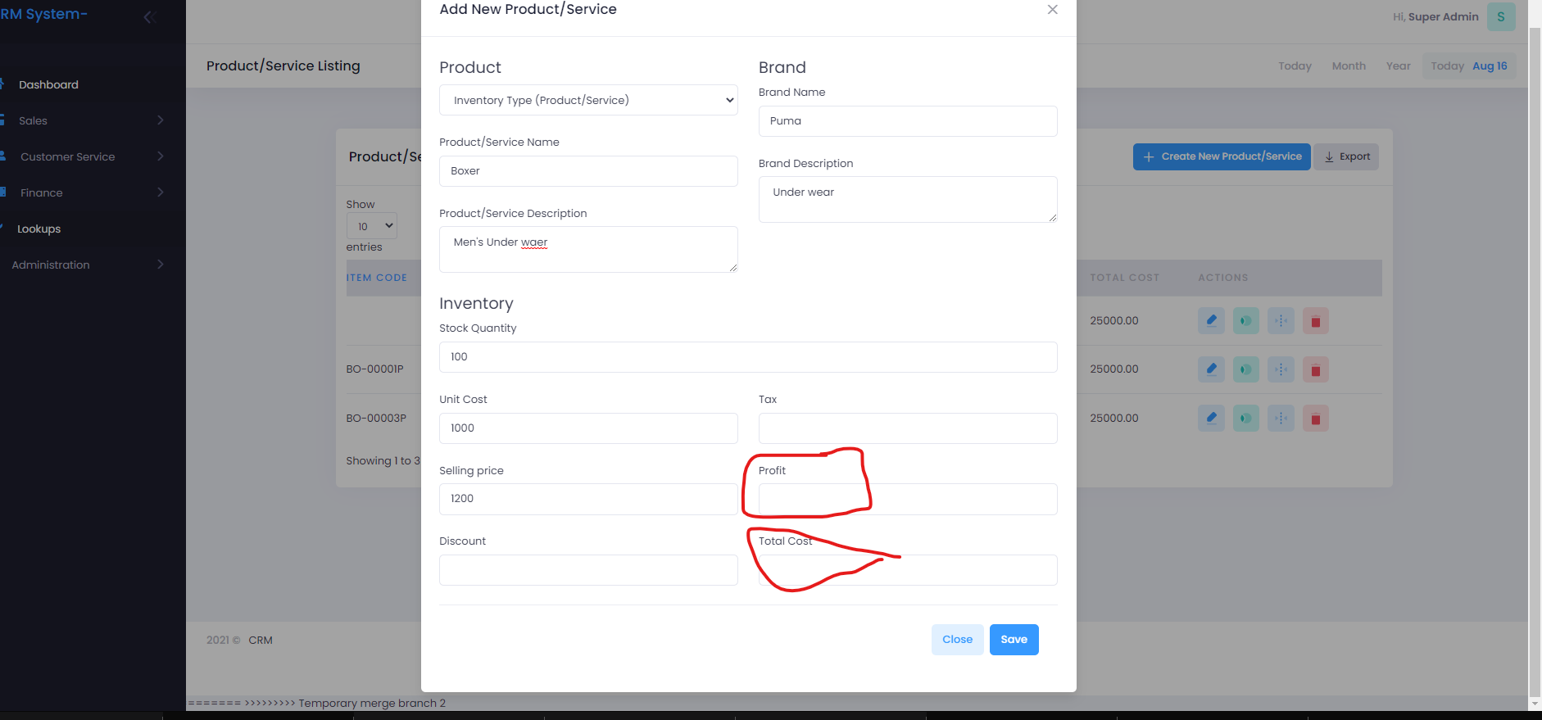

The two circled fields are not populated. **Margin** is also absent on the page.